Tables/charts needed for paper:

- Map of India with state-wise distribution of tutors

- Highest qualification of tutors: pie chart

- Gender distribution (example Table 2)
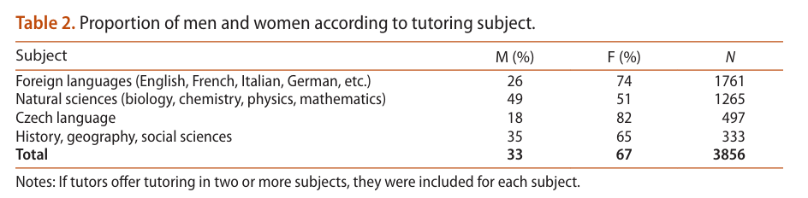

- Occupation of tutors (Table 3)
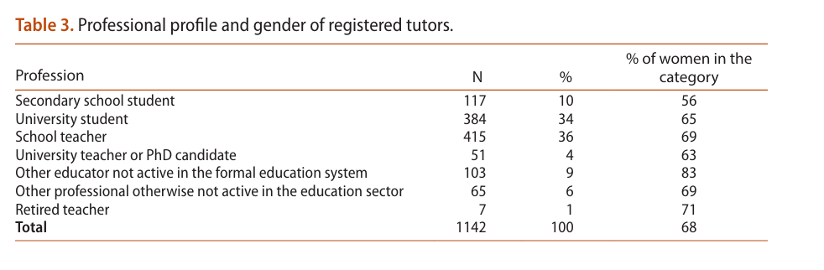

- Average fee by state (figure 4)

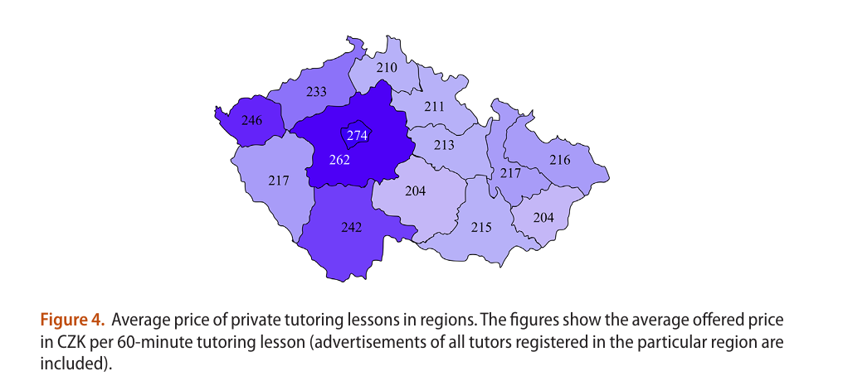
- Subjects distribution (example Figure 1)
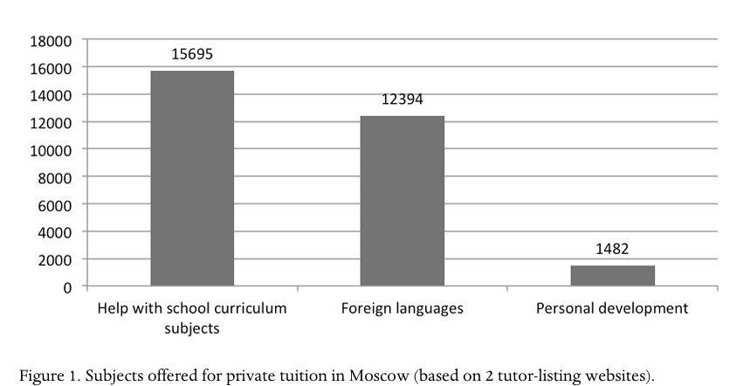

- Years of experience distribution (figure 3 is for age, but we dont have age data, so we can use experience instead)
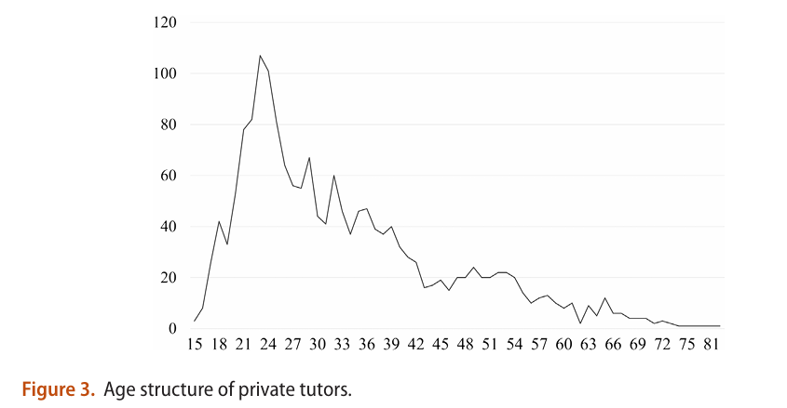

- Subject wise fees (optional, by level): include english, math, foreign language, science/coding (or choose 5 top subjects offered)

